# **Tutorial: Get Started with Tableau Desktop**

*Version: 2019.4*

##### Learn how to connect to data, create data visualizations, present your findings, and share your insights with others.

This tutorial walks you through the features and functions of Tableau Desktop version 2019.4. As you work through this tutorial, you will create multiple views in a Tableau workbook. The steps you'll take and the workbook you'll work in are based on a story about an employee who works at headquarters for a large retail chain. The story unfolds as you step through asking questions about your business and its performance.

You'll learn how to connect to data in Tableau Desktop; build, present, and share some useful views; and apply key features along the way. Budget between one and three hours to complete the steps.

## Here's the story...

Suppose you are an employee for a large retail chain. Your manager just got the quarterly sales report and noticed that sales seem better for some products than for others and profit in some areas is not doing as well as she had expected. Your boss is interested in the bottom line: It's your job to look at overall sales and profitability to see if you can find out what's driving these numbers.

She has also asked you to identify areas for improvement and present your findings to the team. The team can explore your results and act to improve sales and profitability for the company's product lines.

You'll use Tableau Desktop to build a simple view of your product data, map product sales and profitability by region, build a dashboard of your findings, and then create a story to present. Then, you will share your findings on the web so that remote team members can review.

Step 1: Connect to your data

Open Tableau Desktop and begin

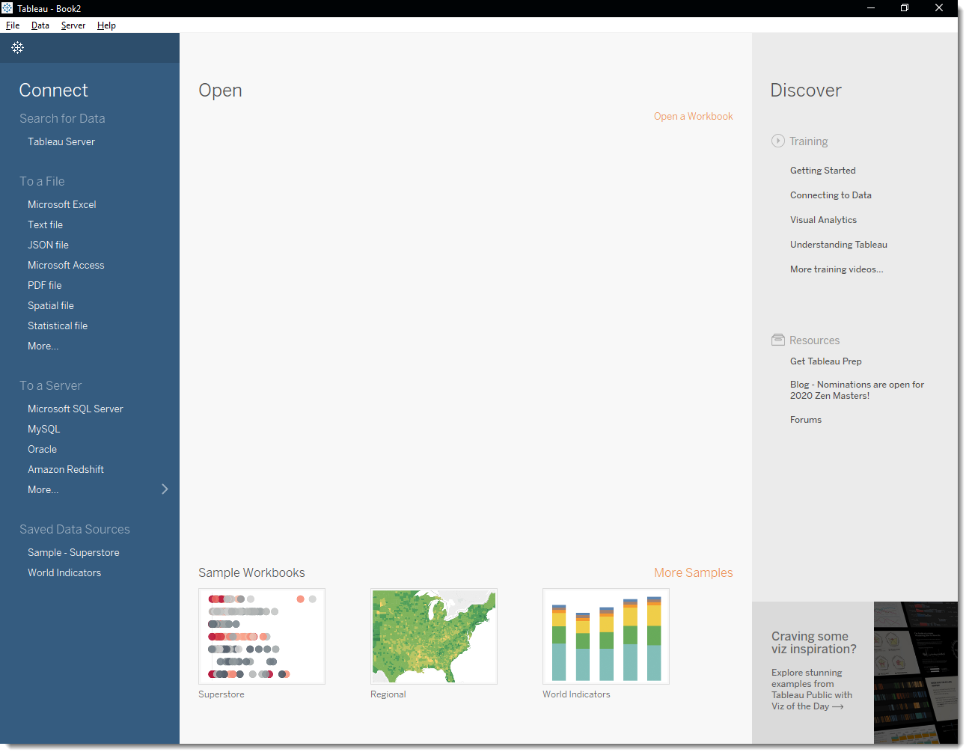

In the **Connect**pane, under **Saved Data Sources**, click on **Sample - Superstore** to connect to the sample data set. 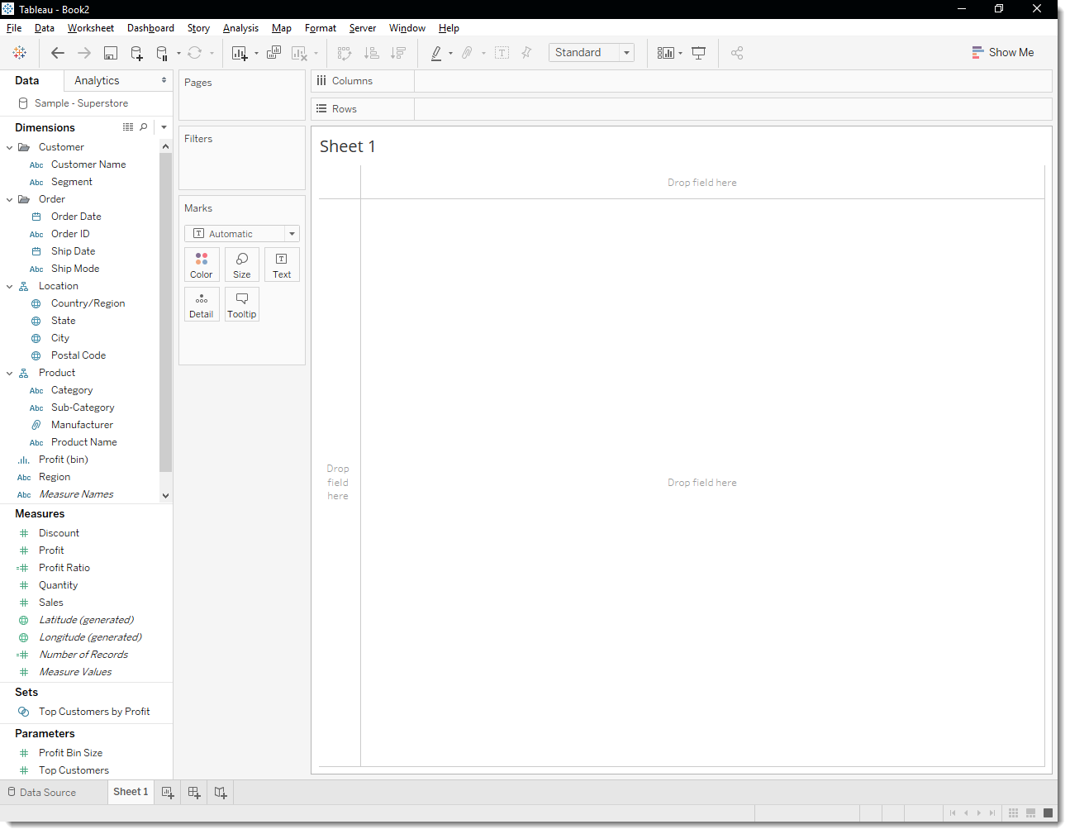

Step 2: Drag and drop to take a first look

Create a view

You set out to identify key areas for improvement, but where to start? With four years' worth of data, you decide to drill into the overall sales data between 2016 and 2019 to see what you find. Start by creating a simple chart.

1. From Dimensions in the Data pane, drag **Order Date** to the **Columns** shelf.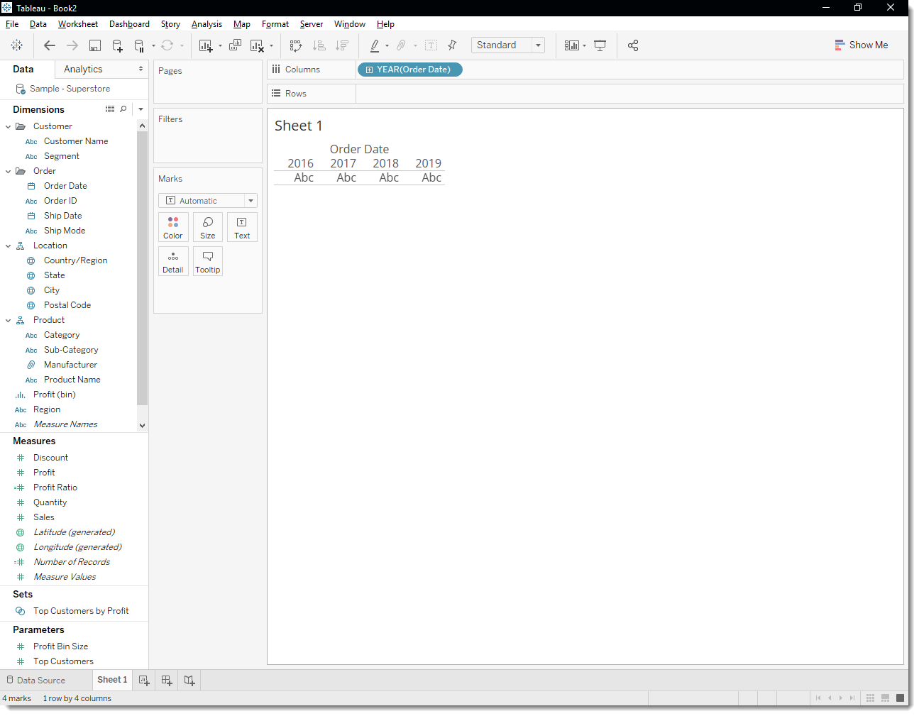
2. From Measures, drag **Sales** to the **Rows** shelf.

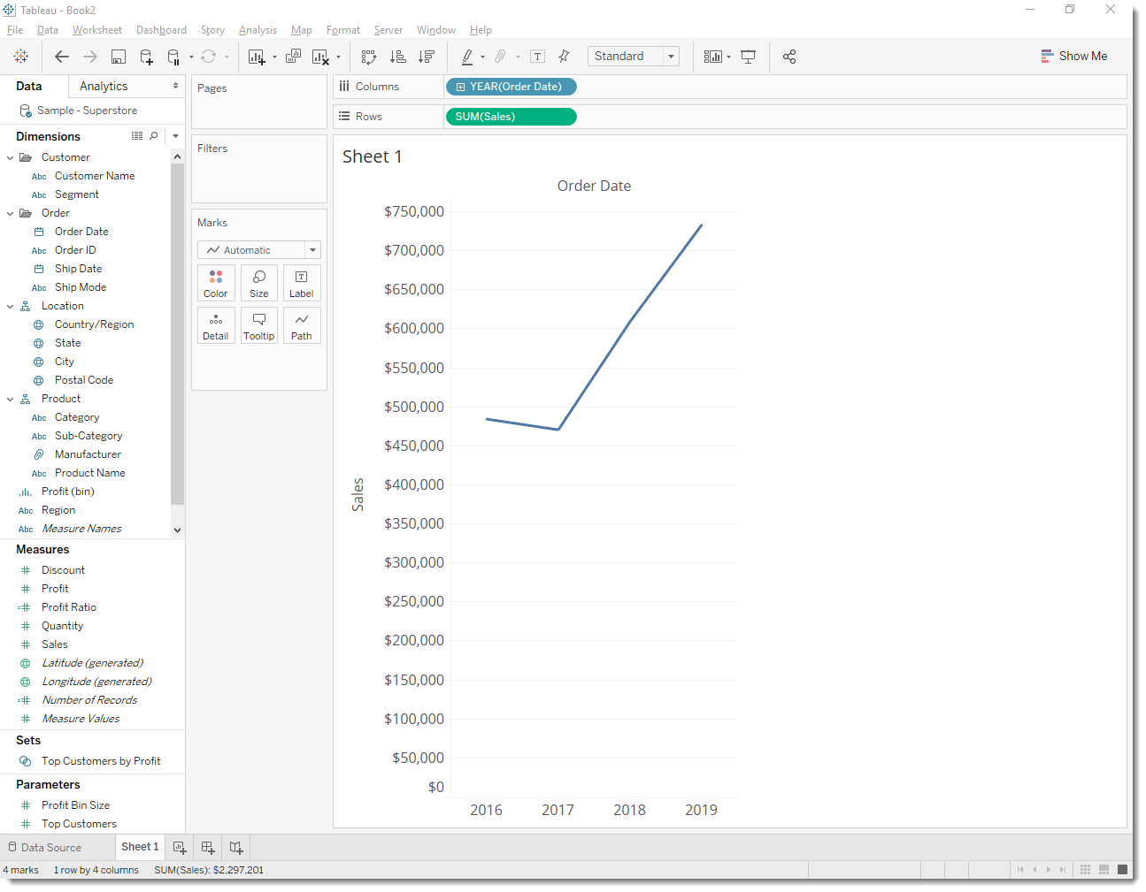

*Any time you create a view that includes time (in this case Order Date),Tableau generates a line chart.*

This line chart shows that sales look pretty good and seem to be increasing over time. This is good information, but it doesn't really tell you much about which products have the strongest sales and if there are some products that might be performing better than others. Since you just got started, you decide to explore further and see what else you can find out.



Click to view steps

Refine your view

To gain more insight into which products drive overall sales, try adding more data. Start by adding the product categories to look at sales totals in a different way.

1. From Dimensions, drag **Category** to the **Columns** shelf and place it to the right of YEAR(Order Date).

Your view updates to a bar chart. By adding a second discrete dimension to the view you can categorize your data into discrete chunks instead of looking at your data continuously over time. This creates a bar chart and shows you overall sales for each product category by year.

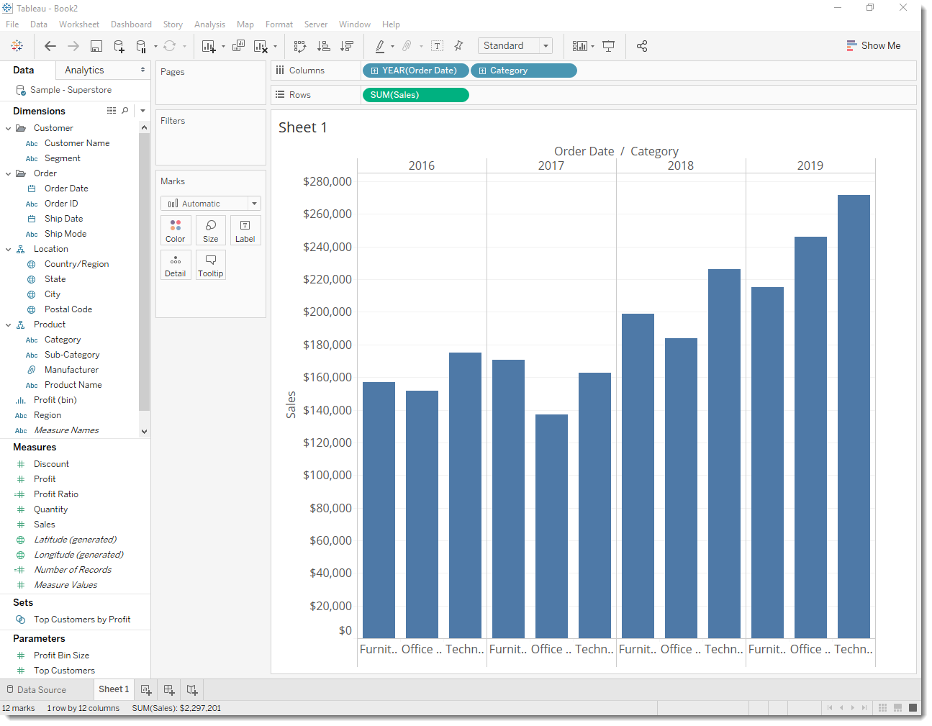

From this view, you can see that sales for furniture is growing faster than sales for office supplies, even though Office Supplies had a good year in 2019. Perhaps you can recommend that your company focus sales efforts on furniture instead of office supplies? Your company sells a lot of different products in those categories, so you'll need more information before you can make a recommendation.

To help answer that question, you decide to look at products by sub-category to our highest selling items. For example, for the Furniture category, you want to see details about bookcases, chairs, furnishings, and tables. Looking at this data might help you gain insights into sales and later, overall profitability, so add sub-categories to your bar chart.

1. Double-click or drag the **Sub-Category** dimension to the **Columns** shelf.

**Note:** You can drag and drop or double-click a field to add it to your view. Tableau makes assumptions about where to add that data and it might not be placed where you expect. You can always click **Undo** to remove the field or drag it off the area where Tableau placed it to start over.

Sub-Category is another discrete field. It creates another header at the bottom of the view and shows a bar for each sub-category (68 marks) broken down by category and year.



Click to view steps

Step 3: Focus your results

Filters and colors are ways you can add more focus to the details that interest you. After you add focus to your data, you can begin to use other Tableau Desktop features to interact with that data.

Add filters to your view

You can use filters to include or exclude values in your view. In this example, you decide to add two simple filters to your worksheet to make it easier to look at product sales by sub-category for a specific year.

1. In the Data pane, under Dimensions, right-click **Order Date** and select **Show Filter**.
2. Repeat the step above for the **Sub-Category** field.

The filters are added to the right-hand side of your view in the order that you selected them. Filters are card types and can be moved around on the canvas by clicking on the filter and dragging it to another location in the view. As you drag the filter, a dark black line appears, showing you where you can drop the filter to move it.

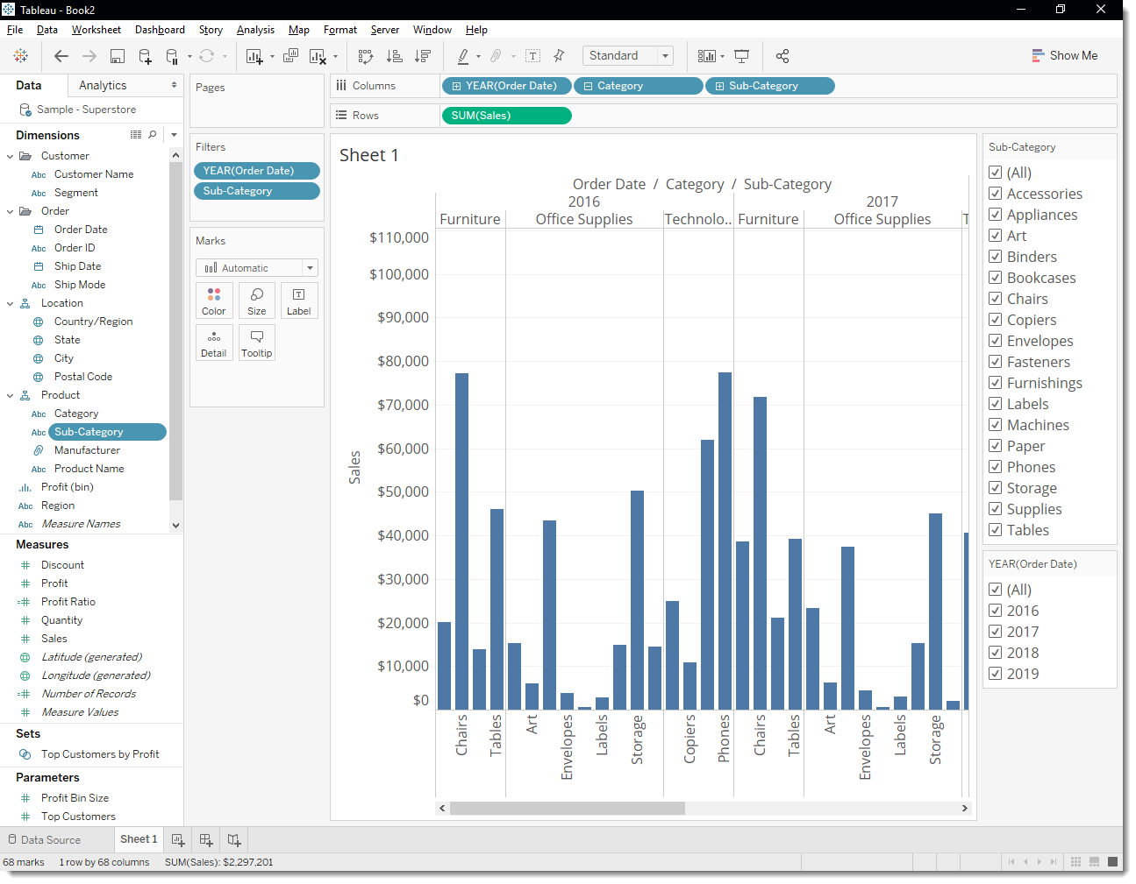



Click to view steps

Add color to your view

Adding filters helps you to sort through all this data—but wow, that’s a lot of blue! Time to do something about that.

Currently, you are looking at sales totals for your various products. You can see that some products have consistently low sales, and might be good candidates for reducing sales efforts for those product lines, but what does overall profitability look like for your different products? You decide to drag **Profit** to color to see what happens.

From Measures, drag **Profit** to **Color** on the Marks card.

By dragging profit to color you now see that you have negative profit in Tables, Bookcases, and even Machines.

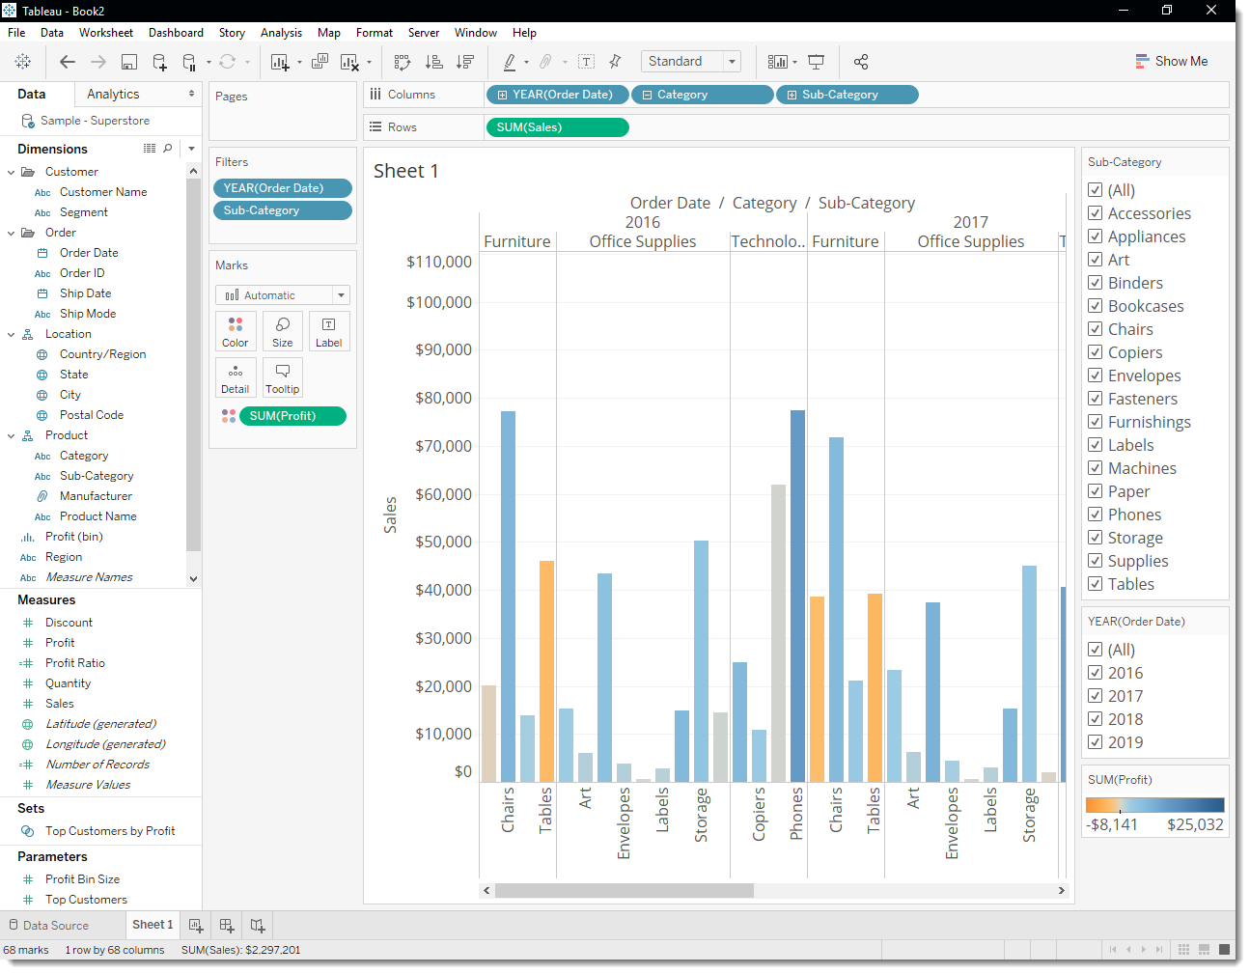

**Note:** Tableau automatically added a color legend and assigned a diverging color palette because your data includes both negative and positive values.



Click to view steps

Find key insights

As you've learned, you can explore your data as you build views with Tableau Desktop. Adding filters and colors helps you better visualize your data and can identify problems right away.

Looking at your view, you saw that you had some unprofitable products, but now you want to see if these products have been unprofitable year over year.

1. In the view, in the **Sub-Category** filter card, clear all the check boxes except **Bookcases**, **Machines**, and **Tables**.

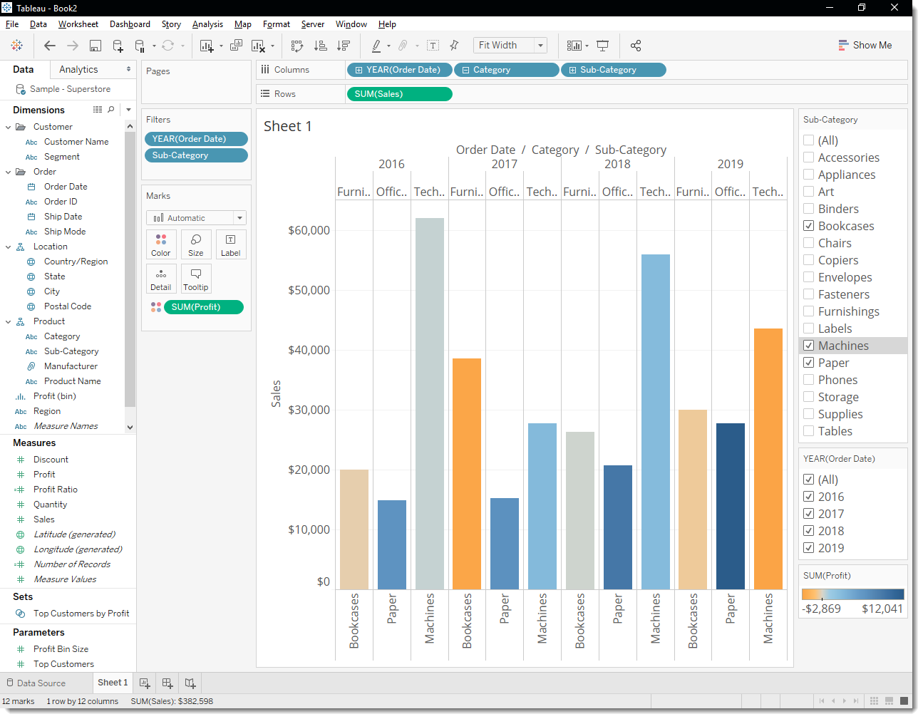

Now you can see that, in some years, Bookcases and Machines were profitable. However, in 2019, Machines became unprofitable. While you've made an important discovery, you want to gather more information before proposing any action items to your boss.

On a hunch, you decide to break up your view by region:

1. Select **All** in the **Sub-Category** filter card to show all sub-categories again.
2. From Dimensions, drag **Region** to the **Rows** shelf and place it to the left of Sum(Sales).

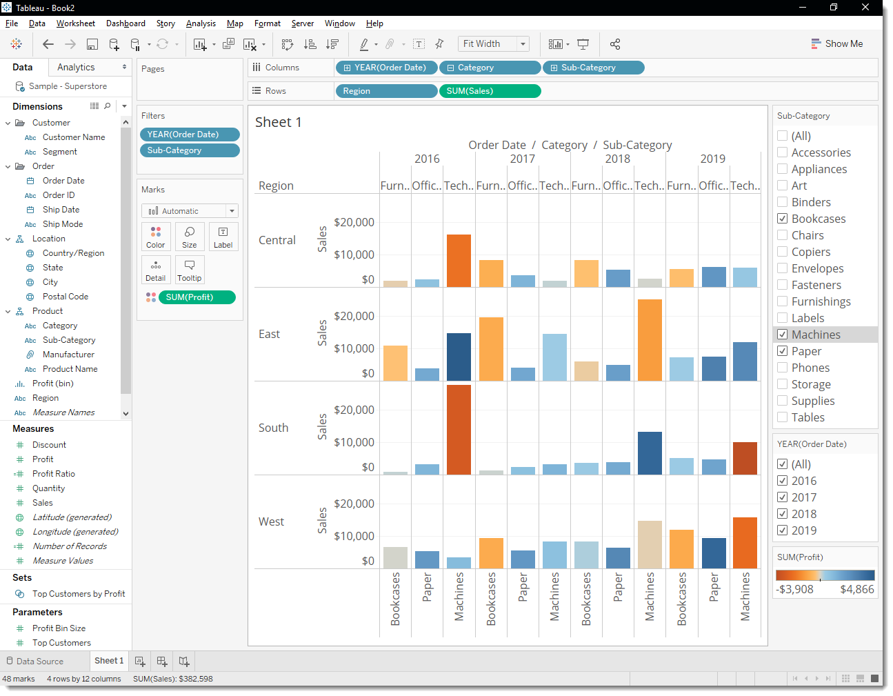Tableau creates a view with multiple axes broken down by region.

Now you see sales and profitability by product for each region. By adding region to the view, you notice that machines in the South are reporting a higher negative profit overall than in your other regions. You've discovered a hidden insight!

1. Select **All** in the **Sub-Category** filter card (if you changed your filter) to show all sub-categories again, name the worksheet and add a title.
2. At the bottom-left of the workspace, double-click **Sheet 1** and type **Sales by Product/Region**.

You choose to focus your analysis on the South, but you don't want to lose the view you've created. In Tableau Desktop, you can duplicate your worksheet to continue where you left off.

1. In your workbook, right-click the **Sales by Product/Region** sheet and select **Duplicate**.

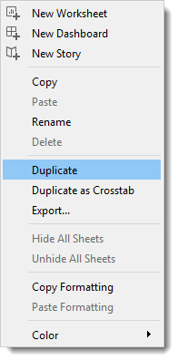

1. Rename the duplicated sheet to **Sales in the South**.
2. In your new worksheet, right click the South region in the view and select Keep Only. This will filter the worksheet to the South.

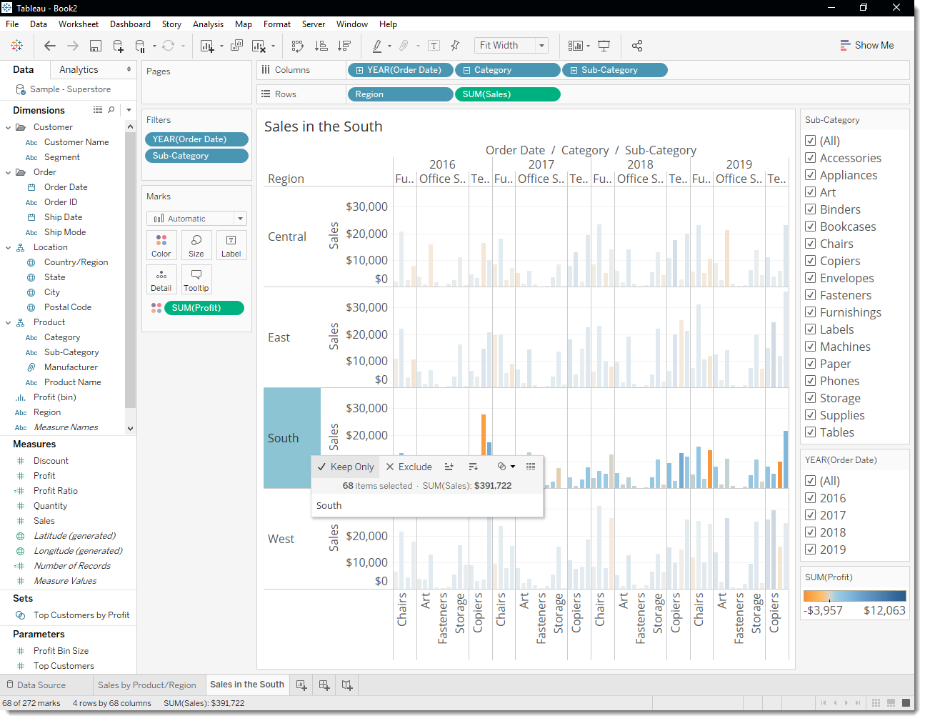To avoid redundancy, we can clean up this sheet just a little. Since your worksheet is for the **South**, we can take Region off the Rows.

Your view updates to look like the image below.

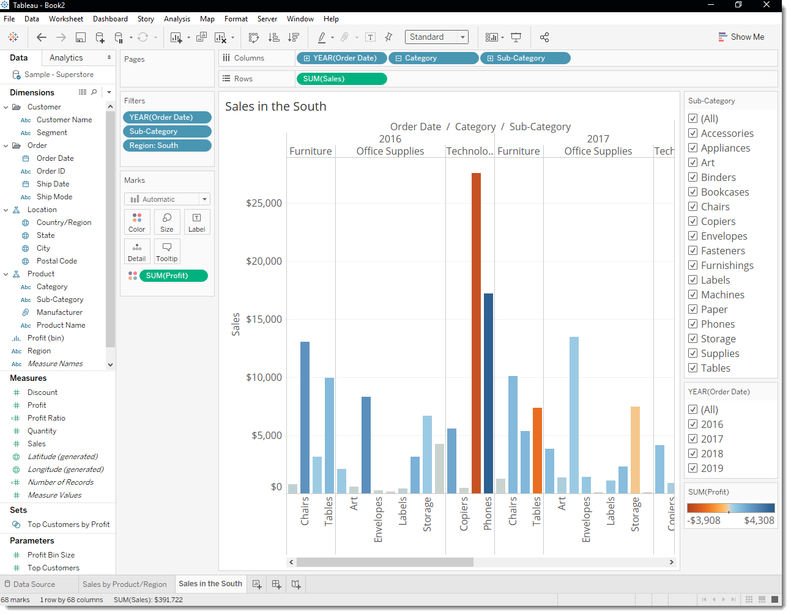

Now you can focus on sales and profit in the South. You immediately see that machine sales had negative profit in 2016 and again in 2019.

1. Save your work by selecting **File** > **Save As**. Give your workbook a name, like **Regional Sales and Profits**



Click to view steps

# **Step 4: Explore your data geographically**

You've built a great view that allows you to review sales and profits by product between 2016 and 2019. And after looking at product sales and profitability in the South, you decide to look for trends or patterns in that region.

Since you're looking at geographic data (the Region field), you have the option to build a map view. Map views are great for displaying and analyzing this kind of information.

For this example, Tableau has already assigned the proper geographic roles to the Country, State, City, and Postal Code fields. That's because it recognized that each of those fields contained geographic data. You can get to work creating your map view right away.

## Build a map view

Start fresh with a new worksheet.

1. Click the **New worksheet** icon at the bottom of the workspace.

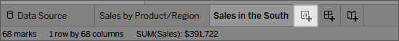

Tableau keeps your previous worksheet and creates a new one so that you can continue exploring your data without losing your work.

1. In the Data pane, double-click **State** to add it to **Detail** on the Marks card.

Since Tableau already knows that state names are geographic data, and because the State dimension is assigned the State/Province geographic role, Tableau automatically creates a map view.



Click to view steps

There is a mark for each of the 48 contiguous states in your data source.

Notice that the Country field is also added to the view. This happens because the geographic fields in Sample - Superstore are part of a hierarchy. Each level in the hierarchy is added as a level of detail.

1. Drag **Region** to the **Filters** shelf, and then filter down to the **South** only.

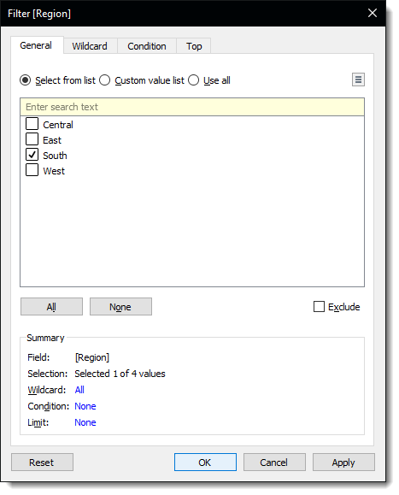

The map view zooms in to the South region, and there is a mark for each state (11 total).

1. Drag the **Sales** measure to **Color** on the Marks card.



Click to view steps

The view automatically updates to a filled map, and colors each state based on its total sales.

Any time you add a continuous measure that contains positive numbers (like Sales) to Color on the Marks card, your filled map is colored blue. Negative values are assigned orange.

1. Click **Color** on the Marks card and select **Edit Colors**.

For this example, you want to see which states are doing well, and which states are doing poorly in sales.

1. In the Palette drop-down list, select **Red-Green Diverging** and click **OK**.

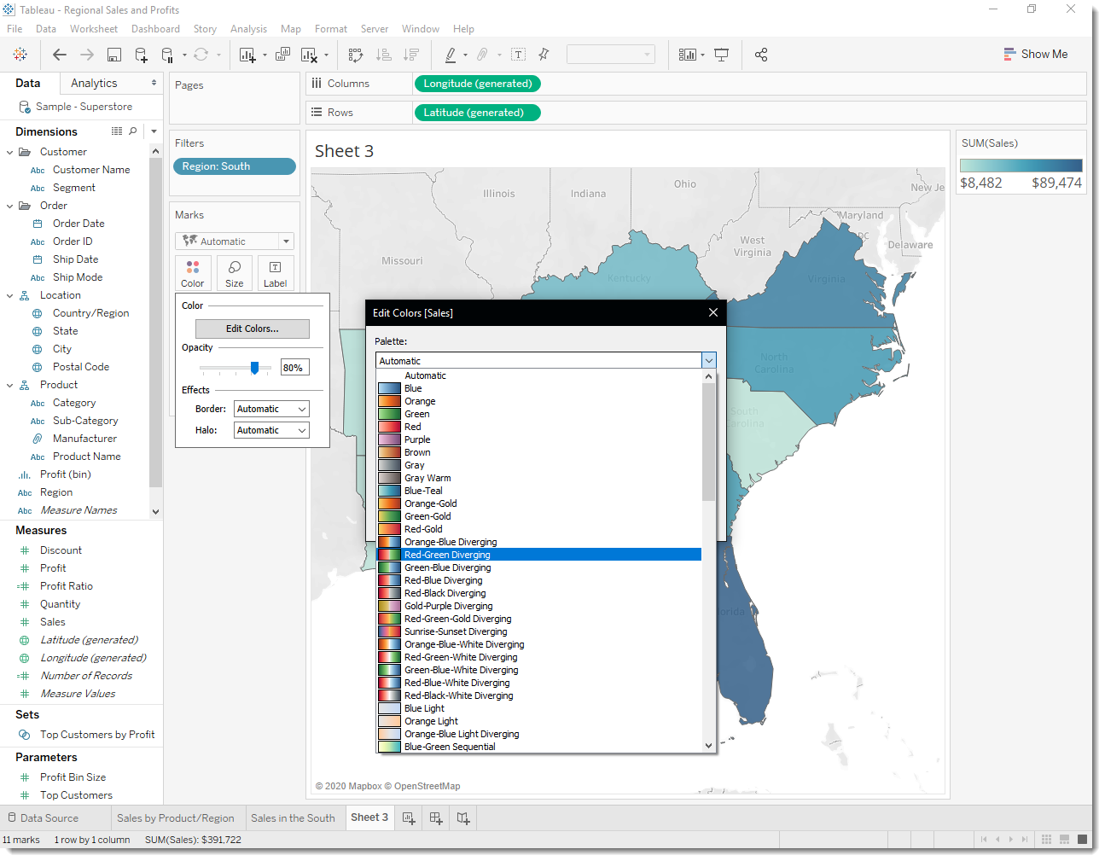This should allow you to quickly see the low performers and the high performers.

Your view updates to look like this:

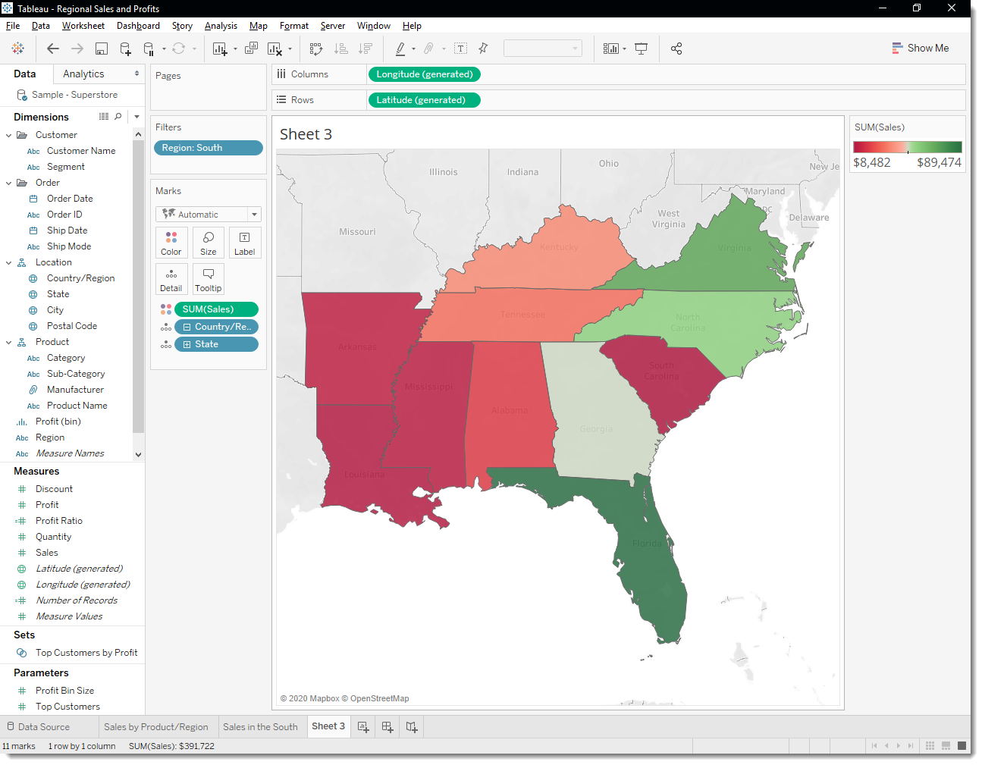

But wait. Everything just went red! What happened?

The data is accurate, and *technically* you can compare low performers with high performers, but is that really the whole story?

Are sales in some of those states really that terrible, or are there just more people in Florida looking to buy your products? Maybe you have smaller or fewer stores in the states that appear red. Or maybe there’s a higher population density in the states that appear green, so there’s just more people to buy your stuff.

Either way, there’s no way you want to show this view to your boss because you aren't confident the data is telling a useful story.

1. Click the **Undo** icon  in the toolbar to return to that nice, blue view.

There’s still a color problem. Everything looks dandy—that’s the problem!

At first glance, it appears that Florida is performing the best. Hovering over its mark reveals a total of 89,474 USD in sales, as compared to South Carolina, for example, which has only 8,482 USD in sales. However, have any of the states in the South been profitable?

1. Drag **Profit** to **Color** on the Marks card to see if you can answer this question.

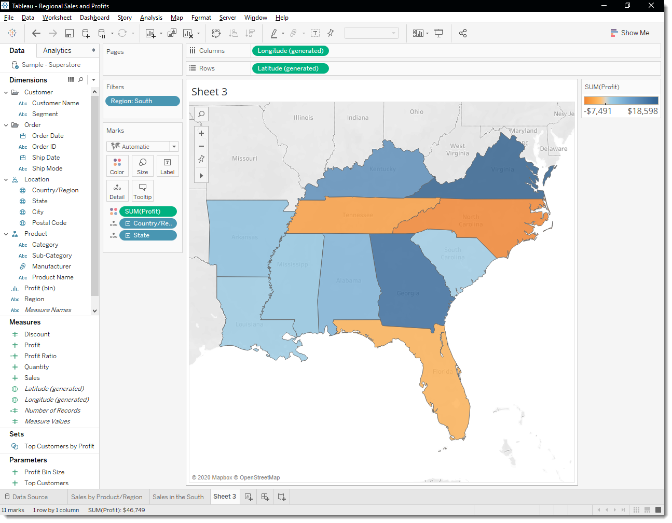

Now that’s more like it! Since profit often consists of both positive and negative values, Tableau automatically selects the Orange-Blue Diverging color palette to quickly show the states with negative profit and the states with positive profit.

It’s now clear that Tennessee, North Carolina, and Florida have negative profit, even though it appeared they were doing great in Sales. But why? You'll answer that in the next step.

Click to view steps

# **Step 5: Drill down into the details**

In the last step you discovered that Tennessee, North Carolina, and Florida have negative profit. To find out why, you decide to drill down even further and focus on what's happening in those three states alone.

## Pick up where your map view left off

As you saw in the last step, maps are great for visualizing your data broadly. A bar chart will help you view the details. To do this, you create another worksheet.

1. Double-click **Sheet 3** and name the worksheet **Profit Map**.
2. Right-click **Profit Map** at the bottom of the workspace and select **Duplicate**. Name this one **Negative Profit Bar Chart**.
3. In the Negative Profit Bar Chart worksheet, click **Show Me**, and then select **horizontal bars**.

Show Me highlights different chart types based on the data you've added to your view.

**Note:** At any time, you can click **Show Me** again to collapse it.

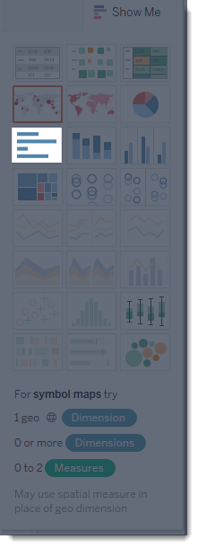

You now have a bar chart again—just like that.

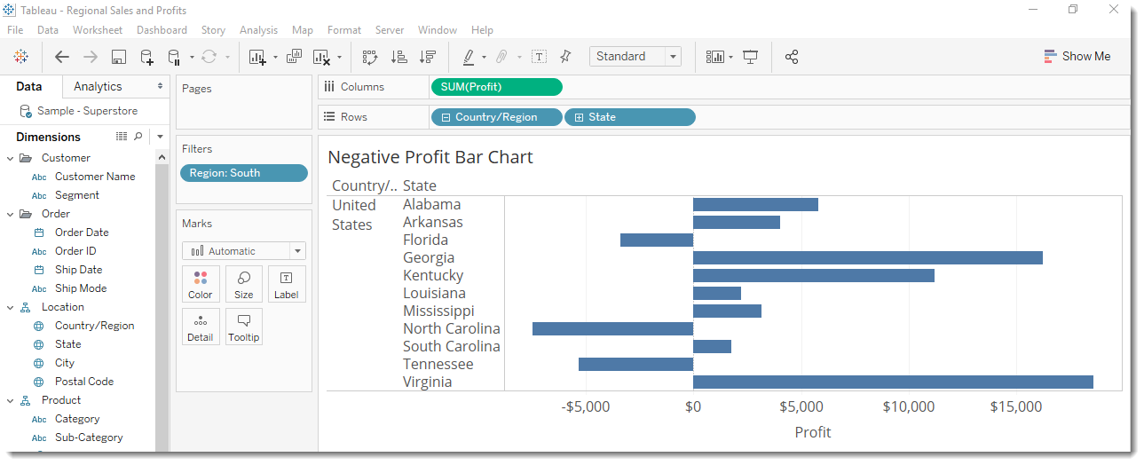

Let’s look at the States with Negative Profit.

1. **Right click** the **SUM(Profit)** pill on the **Columns** Shelf and select **Show** **Filter**

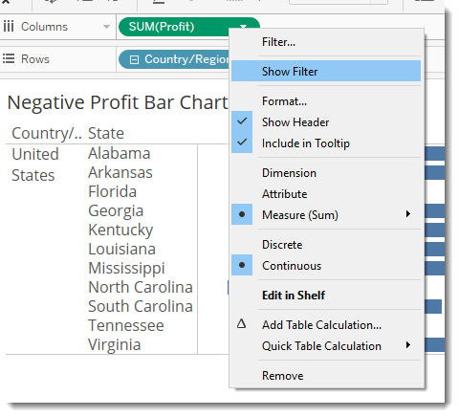

Now you want to look at the data for the cities in these states.

1. In the filter, set the **TO** value to -.01 *(to make sure we capture everything negative)*

This will be the view: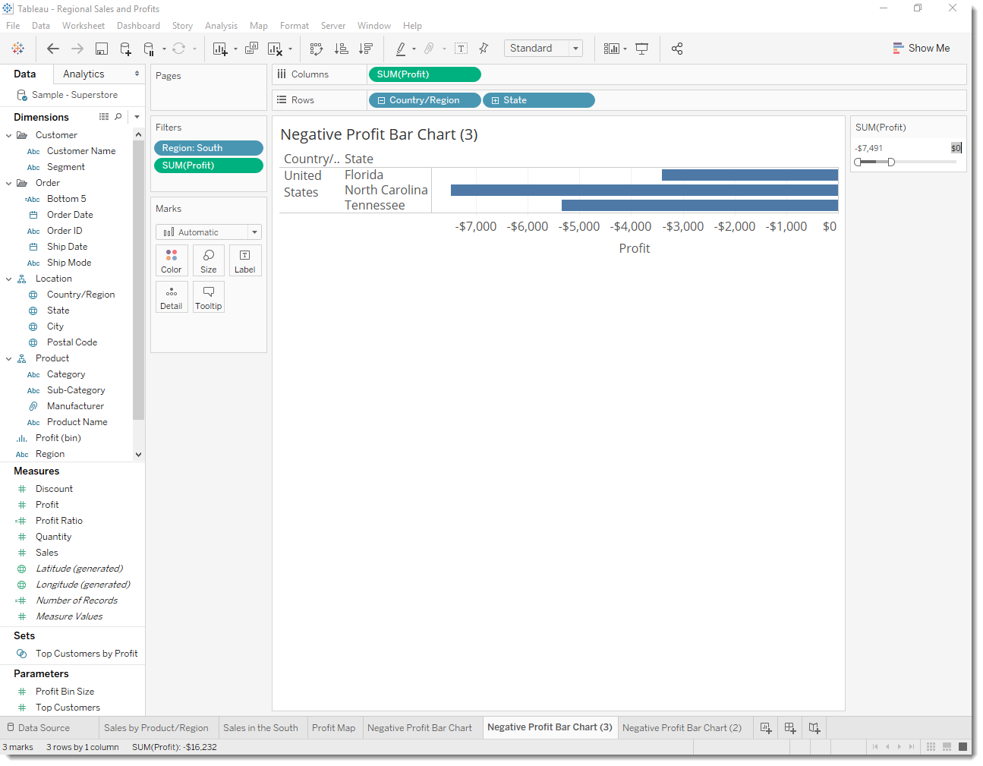

Let’s view this by Cities.

1. **Select** the **+** sign beside the **State** **pill** or over the **State** **Heading** to drill into the City

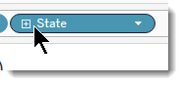 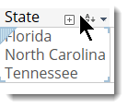

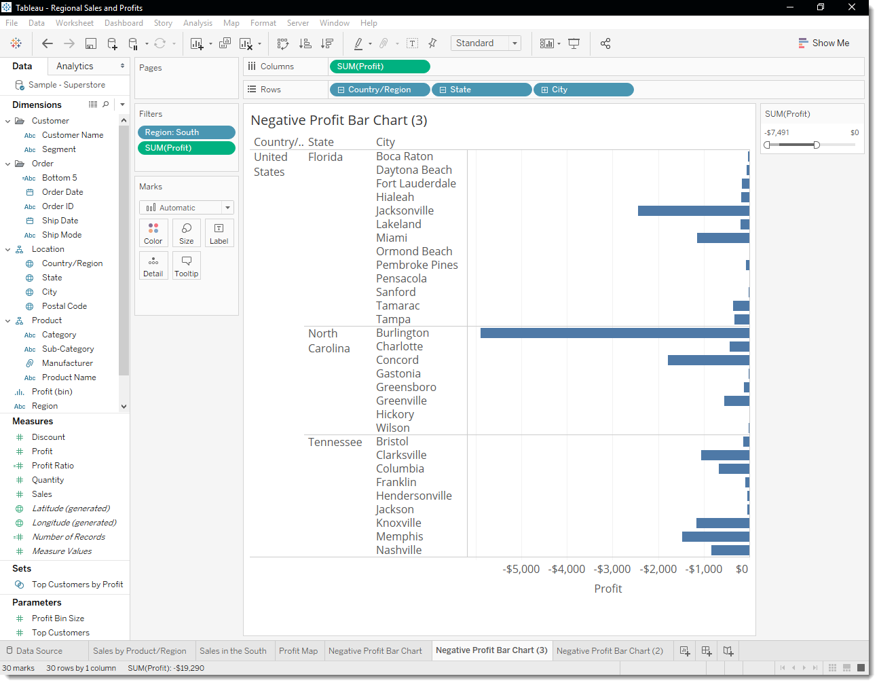There’s almost too much information here, so you decide to filter the view down to the cities with the most negative profit. How will you do this? With a Top N Filter.

## Create a Top *(or Bottom)* Filter

You can use a Top Filter in Tableau Desktop to set a limit to the number of marks displayed in your view. In this case, you want to use the Top Filter to view poor performers.

1. From the Data pane, drag **City** to the **Filters** shelf.
2. In the Filter dialog box, select the **Top** tab, and then do the following:
   1. Click **By field**.
   2. Click the **Top** drop-down and select **Bottom** to reveal the poorest performers.
   3. Type **5** in the text box to show the bottom 5 performers in your data set and then select **OK**.

Tableau Desktop has already selected a field (Profit) and aggregation (Sum) for the Top N Filter based on the fields in your view. These settings ensure that your view will display only the five poorest performing cities by sum of profit.

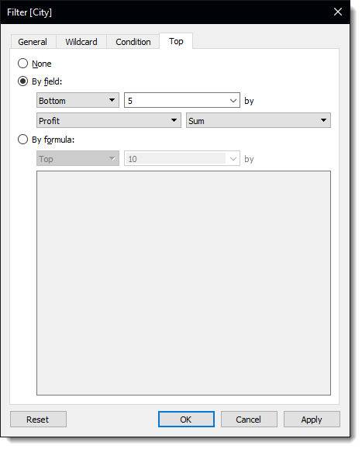

**MY VIEW IS BLANK – What Happened?!**

That's a great question, and a great reason to introduce an important concept.

**Tableau Order of Operations**

The Tableau Order of Operations, also known as the query pipeline, is the order that Tableau performs various actions, such as the order in which it applies your filters to the view.

Tableau applies filters in the following order:

* 1. Extract Filters
  2. Data Source Filters
  3. Context Filters
  4. Top N Filters
  5. Dimension Filters
  6. Measure Filters

*The order in which you create filters or arrange them on the Filters shelf has nothing to do with the order in which Tableau applies those filters to your view.*

The good news is you can tell Tableau to change this order when you notice something strange happening with the filters in your view, like when it completely disappears!!

What has happened is that Tableau has filtered the South, Profit, and Top Cities. Since the Top N Filters is calculated 4th on the list above, and the others are 5th and 6th on the on the list (Dimension and Measure filters respectively). Tableau is filtering the 5 worst performing cities first and then filtering to the Region and then for Negative Profit.

The Worst Performing Cities are:

* Philadelphia, Pennsylvania
* Houston, Texas
* San Antonio, Texas
* Lancaster, Ohio
* Chicago, Illinois

None of these are in the Southern Region

All we need to do is add a filter to context, but which one? This will tell Tableau to filter that field first, regardless of where it falls on the order of operations. There are three fields on the Filters shelf: Region (a dimension filter), City (a top N filter), and SUM(Profit) (a measure filter).

It helps to put it into a sentence structure to reach your goal.

**We would like to see the Worst Performing 5 cities within the Southern Region.**

Since the constant variable is the ***Southern Region***, lets put that on the Context filter.

1. Right click the **Region**: **South** Filter and select – **Add to Context**

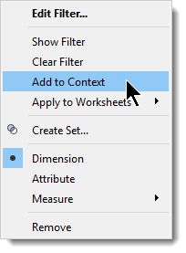

This will fix your view and turn the filter selection Grey to indicate that it is a context filter

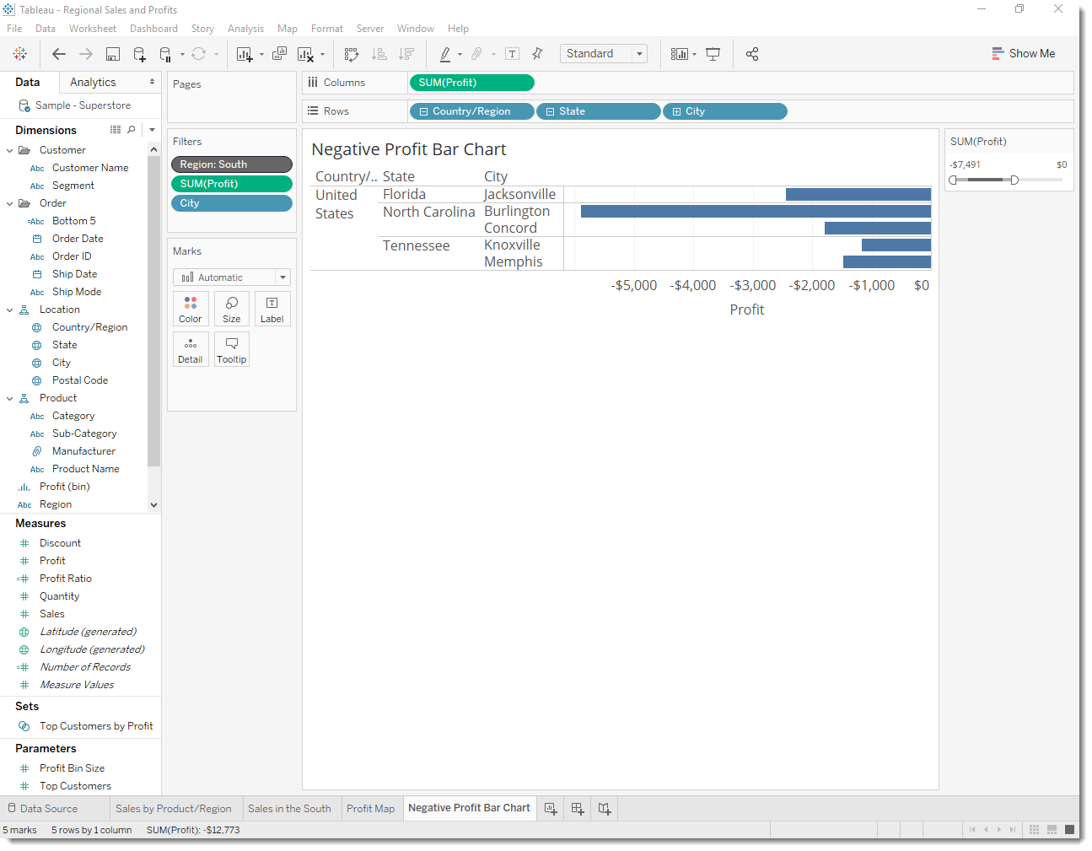

Now that you've focused your view to the least profitable cities, you can investigate further to identify the products responsible.

*Also, lets finally take Country/Region out of the view.

## Identify the troublemakers

You decide to break up the view by Sub-Category to identify the products dragging profit down. You know that the Sub-Category field contains information about products sold by location, so you start there.

1. Drag **Sub-Category** to the **Rows** shelf and place it to the right of City.
2. Drag **Profit** to **Color** on the Marks card to make it easier to see which products have negative profit.
3. In the Data pane, right-click **Order Date** and select **Show Filter**.

You can now explore negative profits for each year if you want, and quickly spot the products that are losing money.

Machines, tables, and binders don’t seem to be doing well. So what if you stop selling those items in Jacksonville, Concord, Burlington, Knoxville, and Memphis?

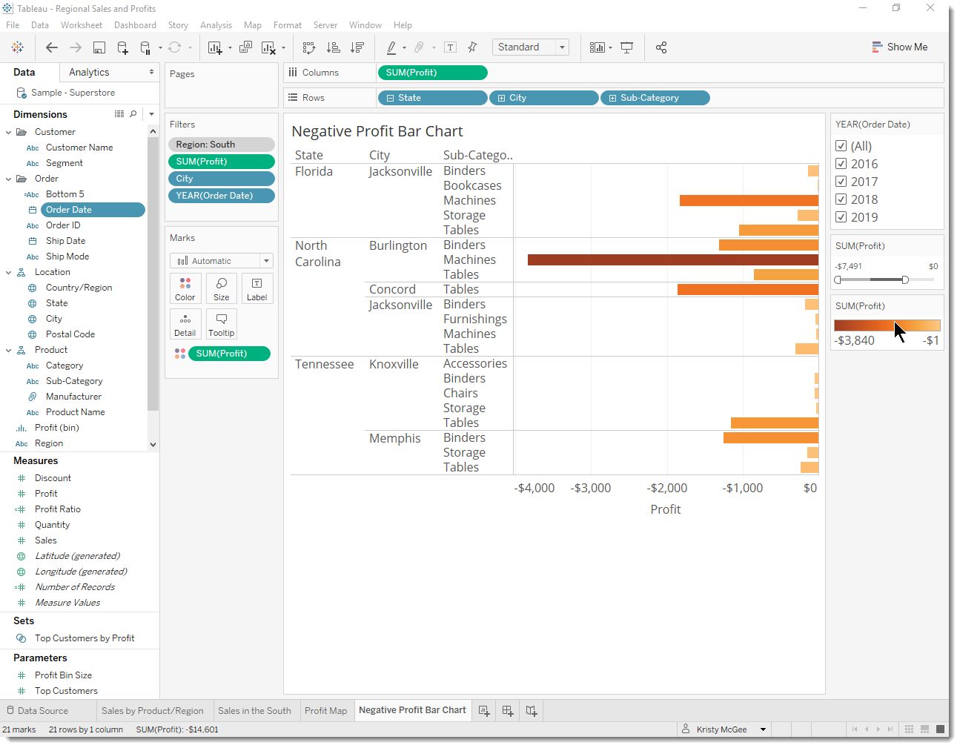

**Verify your findings**

Will eliminating binders, machines, and tables improve profits in Florida, North Carolina, and Tennessee? To find out, you can filter out the problem products to see what happens.

1. Go back to your map view by clicking the **Profit Map** sheet tab.
2. On the Data pane, right-click **Sub-Category** and select **Show Filter**.

A filter card for all the products you offer appears next to the map view. This will come in handy in just a second.

1. From Measures, drag **Profit** and **Profit Ratio** to **Label** on the Marks card.

Now you can see the exact profit of each state without having to hover your cursor over them.

1. On the Data pane, right-click **Order Date** and select **Show Filter** to provide some context for the view.

A filter card for YEAR(Order Date) appears in the view. You can now view profit for all years or for a combination of years. This might be useful for your presentation.

1. Clear **Binders**, **Machines**, and **Tables** from the list on the Sub-Category filter card in the view.

As you clear each member, the profit for Tennessee, North Carolina, and Florida improve, until finally, each has a positive profit.

Binders, machines, and tables are responsible for the losses in Tennessee, North Carolina, and Florida, but not for the rest of the South. Do you notice how profit decreases for some of the other states as you clear items from the filter card? For example, if you toggle **Binders** on the Sub-Category filter card, profit drops by four percent in Arkansas. You can deduce that Binders are profitable in Arkansas.

You want to share this discovery with the team by walking them through the same steps you took.

1. Select **(All)** on the Sub-Category filter card to include all products again.

Now you know that machines, tables, and binders are problematic products for your company. In focusing on the South, you see that these products have varying impact on profit. This might be a worthwhile conversation to have with your boss.

Next, you'll assemble the work you've done so far in a dashboard so that you can clearly present your findings.

# **Step 6: Build a dashboard to show your insights**

You’ve created four worksheets, and they're communicating important information that your boss needs to know. Now you need a way to say, "Hey, here’s the deal. See how we've got negative profit in Tennessee, North Carolina, and Florida? This is one of the reasons why."

Tableau has an app for that, or at least a sheet: It's called a dashboard. You can use dashboards to display multiple worksheets at once, and—if you want—make them interact with one another.

## Set up your dashboard

You want to emphasize that certain items sold in certain places are doing poorly. Your bar graph view of profit and your map view demonstrate this point nicely.

1. Click the **New dashboard** button.



1. From the Dashboard pane on the left, drag **Sales in the South** to your empty dashboard.
2. Drag **Profit Map** to your dashboard and drop it on top of the Sales in the South view.

Your view will update to look like this:

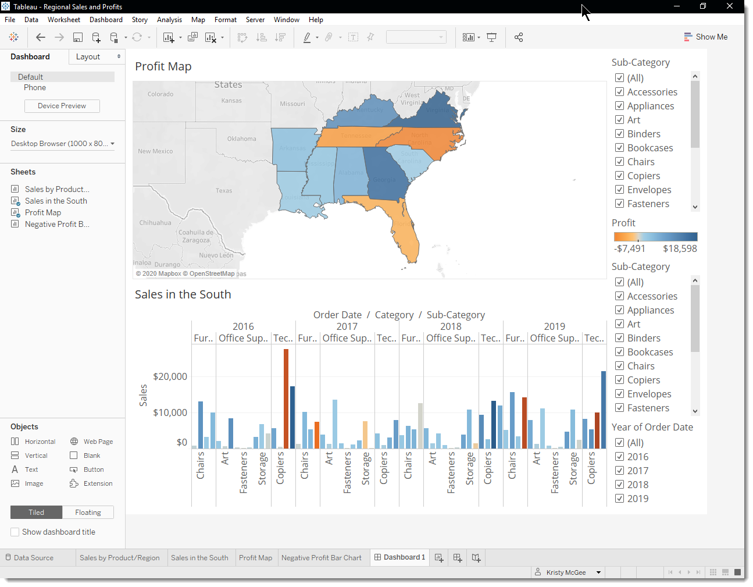

Now you can see both views at once. Nice!

Sadly, the bar chart is a bit squished, which isn’t helping your boss understand your data.

## Arrange your dashboard

It's not easy to see details for each item in Sub-Category from your Sales in the South bar chart. Plus, because we have the map in view.

Resolving these issues will give you more room to communicate the information you need.

1. On the Sales in the South view, right-click in the column area under **Category** column header, and clear **Show header.**

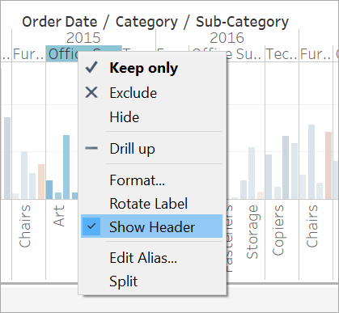

You've now hidden unnecessary columns and rows from your dashboard while preserving the breakdown of your data.

1. Right-click the **Profit Map** title and select **Hide Title**.

The title Profit Map is hidden from the dashboard and more space is created.

1. Repeat this step for the **Sales in the South** view title.
2. Select the first **Sub-Category** filter card on the right side of your view, and at the top of the card, click the **Remove** icon .
3. Repeat this step for the second **Sub-Category** filter card and one of the **Year of Order Date** filter cards.
4. Click on the **Profit color legend** and drag it from the right to below Sales in the South.
5. Finally, select the remaining **Year of Order Date** filter, click its drop-down arrow, and then select **Floating**. Move it to the white space in the map view. In this example, it is placed just off the East Coast, in the Atlantic Ocean.

Try selecting different years on the Year of Order Date filter. Ooh, your data is quickly filtered to show that state performance varies year by year. That's nice, but it could be made even easier to compare.

1. Click the drop-down arrow at the top of the **Year of Order Date** filter, and select **Single Value (Slider)**.

Your view updates to look like this:

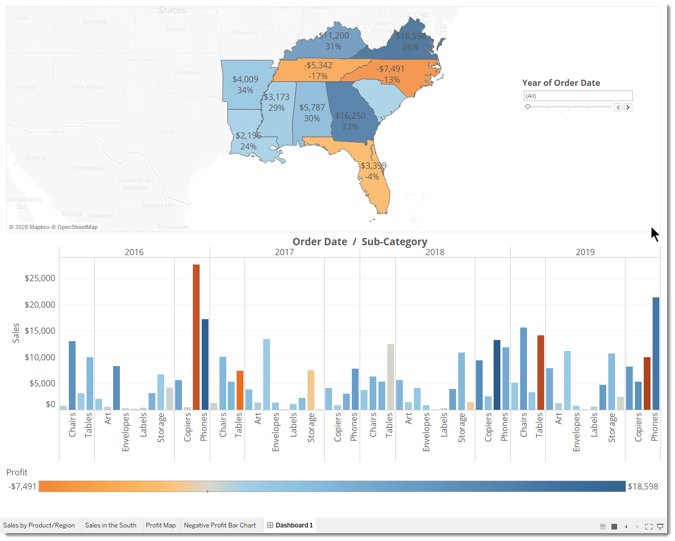

That's more like it! Now, you can easily compare profit and sales by year. But that’s not so different from a couple pictures in PowerPoint—and you're using Tableau.



Click to view steps

## Add interactivity

Wouldn't it be great if you could view which sub-categories are profitable in specific states?

1. Select **Profit Map** in the dashboard and click the **Use as filter** icon  in the upper right-hand corner.
2. Select a state within the map.

The Sales in the South bar chart automatically updates to show just the sub-category sales in the selected state. You can quickly see which sub-categories are profitable.

1. Click outside of the U.S. to clear your selection.

You also want viewers to be able to see the change in profits based on the order date.

1. Select the **Year of Order Date** filter, click its drop-down arrow, and select **Apply to Worksheets** > **Selected Worksheets**.
2. In the Apply Filter to Worksheets dialog box, select **All in dashboard**, and then click **OK**.

This option tells Tableau to apply the filter to all worksheets in the dashboard that use this same data source.

Explore state performance by year with your new, interactive dashboard!

Here, we filter Sales in the South to only items sold in North Carolina, and then explore year by year profit.



Click the image to view the steps

## Rename and go

You show your boss your dashboard, and she loves it. She's named it "Regional Sales and Profit," and you do the same by double-clicking the **Dashboard 1** tab and typing **Regional Sales and Profit**.

In her investigations, your boss also finds that the decision to introduce machines in the North Carolina market in 2019 was a *bad idea*.

Your boss is glad she has this dashboard to explore with, but she also wants you to present a clear action plan to the larger team. You're tasked with creating a PowerPoint with your findings.

# **Step 7: Build a story to present**

You want to share your findings with the larger team. Together, you might reevaluate selling machines in North Carolina.

Instead of having to guess which key insights your team is interested in, and including them in a PowerPoint presentation, you decide to create a story in Tableau. This way, you can walk viewers through your data discovery process, and you have the option to interactively explore your data to answer any questions that come up during your presentation.

## Create your first story point

For the presentation, you'll start with an overview.

1. Click the **New story** button.

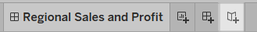

You're presented with a blank workspace that reads, "Drag a sheet here." This is where you'll create your first story point.

If you’re thinking that blank stories look a lot like blank dashboards, that's because they do. And like a dashboard, you can drag worksheets over to present them. You can also drag dashboards over to present them in your story.

1. From the Story pane on the left, drag the **Sales in the South** worksheet onto your view.
2. Add a caption—maybe "Sales and profit by year"—by editing the text in the gray box above the worksheet.

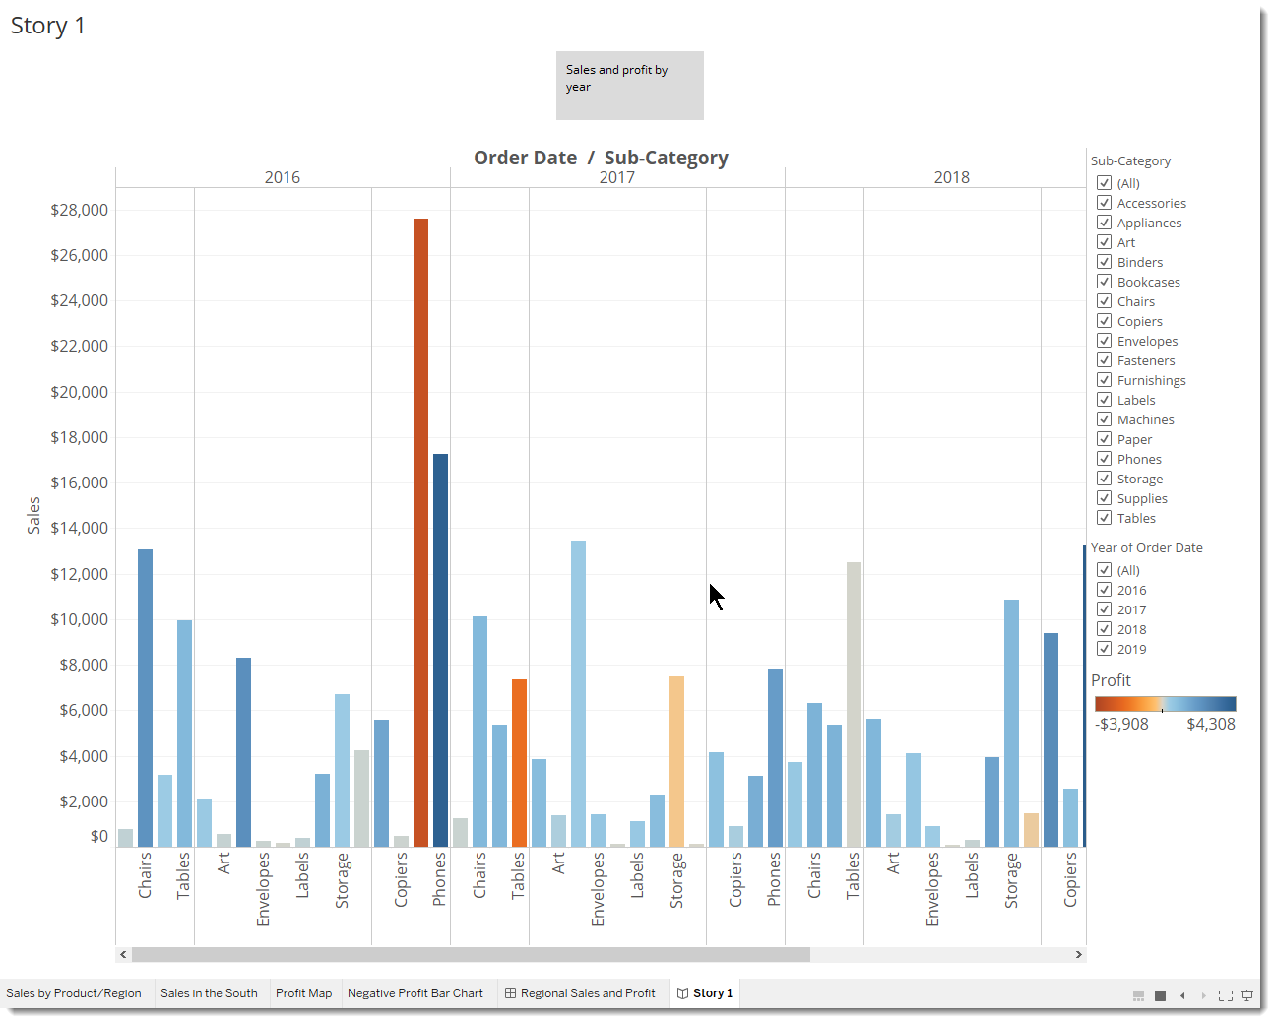

This story point will be a useful way to acquaint viewers with your data.

But you want to tell a story about selling machines in North Carolina, so it's time to take a step in that direction.

## Highlight machine sales

To bring machines into the picture, you can leverage the Sub-Category filter included in your Sales in the South bar chart.

1. In the Story pane, click **Duplicate** to duplicate the first caption.

Continue working where you left off but know that your first story point will be exactly as you left it.

1. Since you know you’re telling a story about machines, on the Sub-Category filter, clear the selection for **(All)**, then select **Machines**.

Now your viewers can quickly identify the sales and profit of machines by year.

1. Add a caption to underscore what your viewers see, for example, "Machine sales and profit by year."

You've successfully shifted the focus to machines, but you realize that something seems odd: In this view, you can't single out which state is contributing to the loss.

You'll address this in your next story point by introducing your map.

1. In the Story pane, select **Blank**.

Click to view steps

## Make your point

The bottom line is that machines in NC lose your company money. You discovered that in the dashboard you created. Looking at overall sales and profit by year doesn't demonstrate this point alone, but regional profit can.

1. Drag your dashboard **Regional Sales and Profit** onto the canvas.

This gives viewers a new perspective on your data: Negative profit catches the eye.

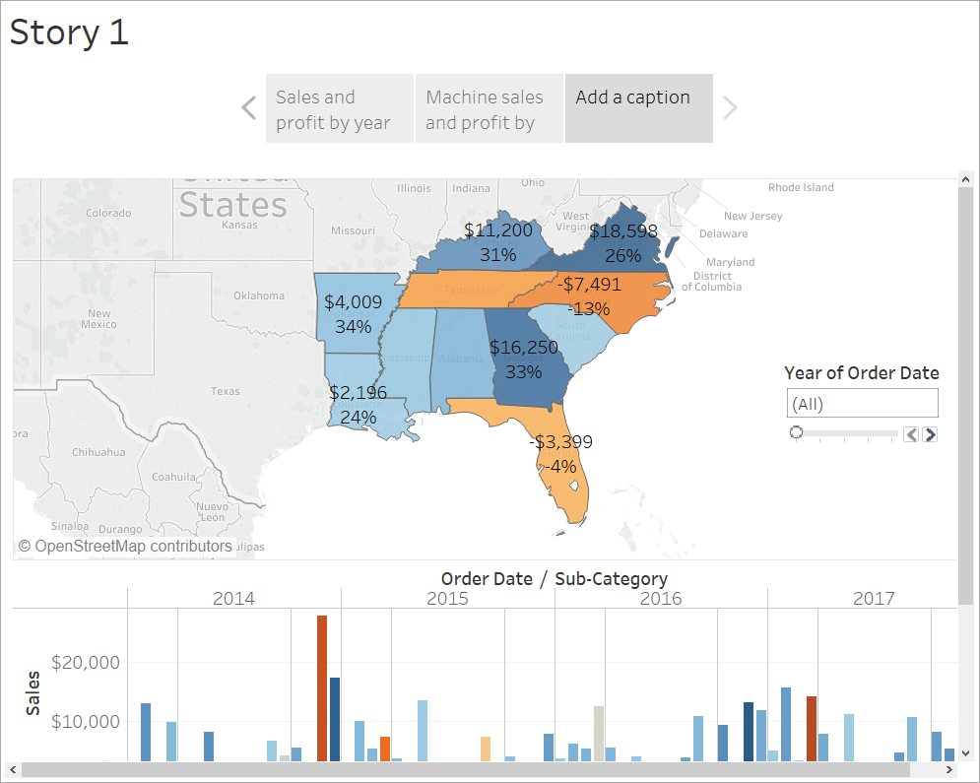

1. Add a caption like, "Underperforming items in the South."

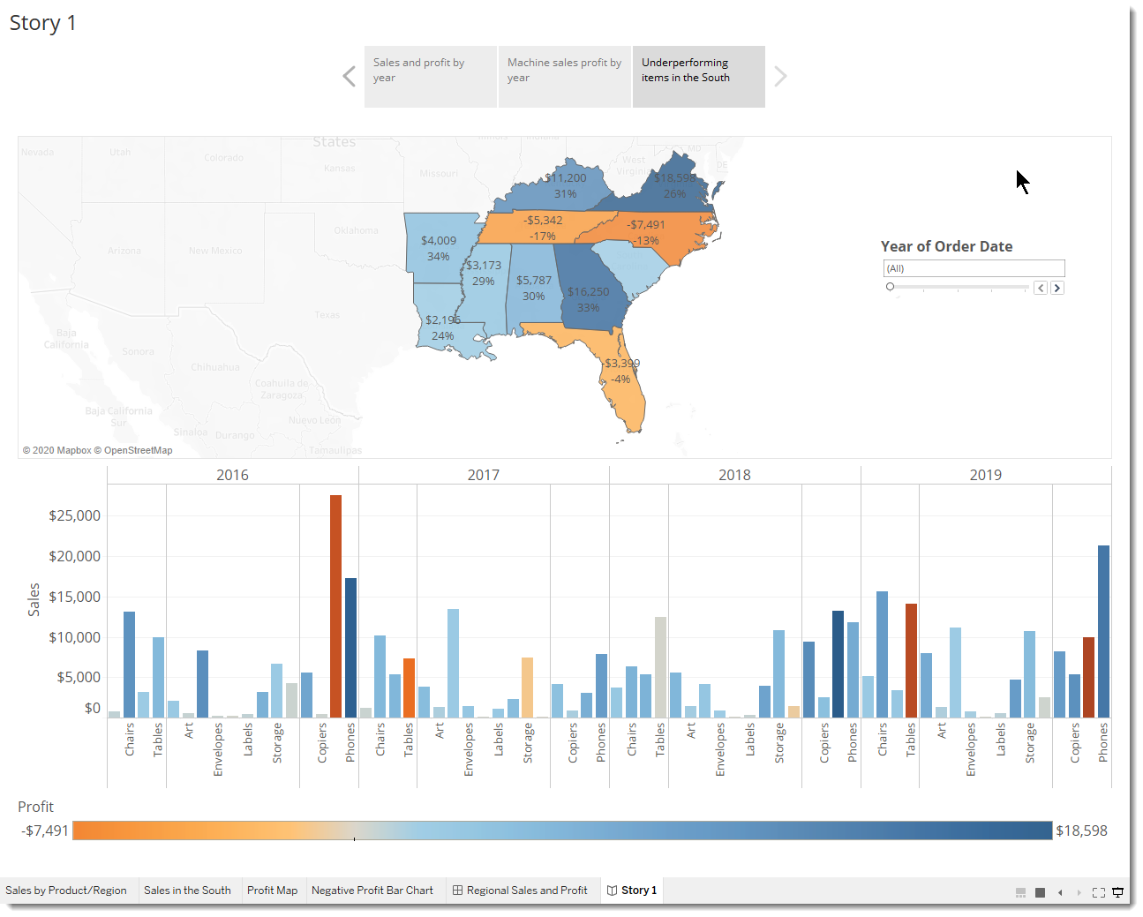

To narrow your results to just North Carolina, start with a duplicate story point.

1. Select **Duplicate** to create another story point with your Regional Profit dashboard.
2. Select **North Carolina** on the map and notice that the bar chart automatically updates.
3. Select **All**on the Year of Order Date filter card.
4. Add a caption, for example, "Profit in NC, 2016-2019."

Now you can walk viewers through profit changes by year in North Carolina. To do this, you will create four story points:

1. Select **Duplicate** to begin with your Regional Profit dashboard focused on North Carolina.
2. On the Year of Order Date filter, click the right arrow button so that **2016** appears.
3. Add a caption, for example, "Profit in NC, 2016," and then click **Duplicate**.
4. Repeat steps 2 and 3 for years 2017, 2018, and 2019.

Now viewers will have an idea of which products were introduced to the North Carolina market when, and how poorly they performed.



Click to view steps

**Finishing touches**

On this story point, which focuses on data from 2019, you want to describe your findings. A caption simply won't do.

1. In the left-hand pane, select **Drag to add text** and drag it onto your view.
2. Enter a description for your dashboard that emphasizes the poor performance of machines in North Carolina, for example, "Introducing machines to the NC market in 2019 resulted in losing a significant amount of money."

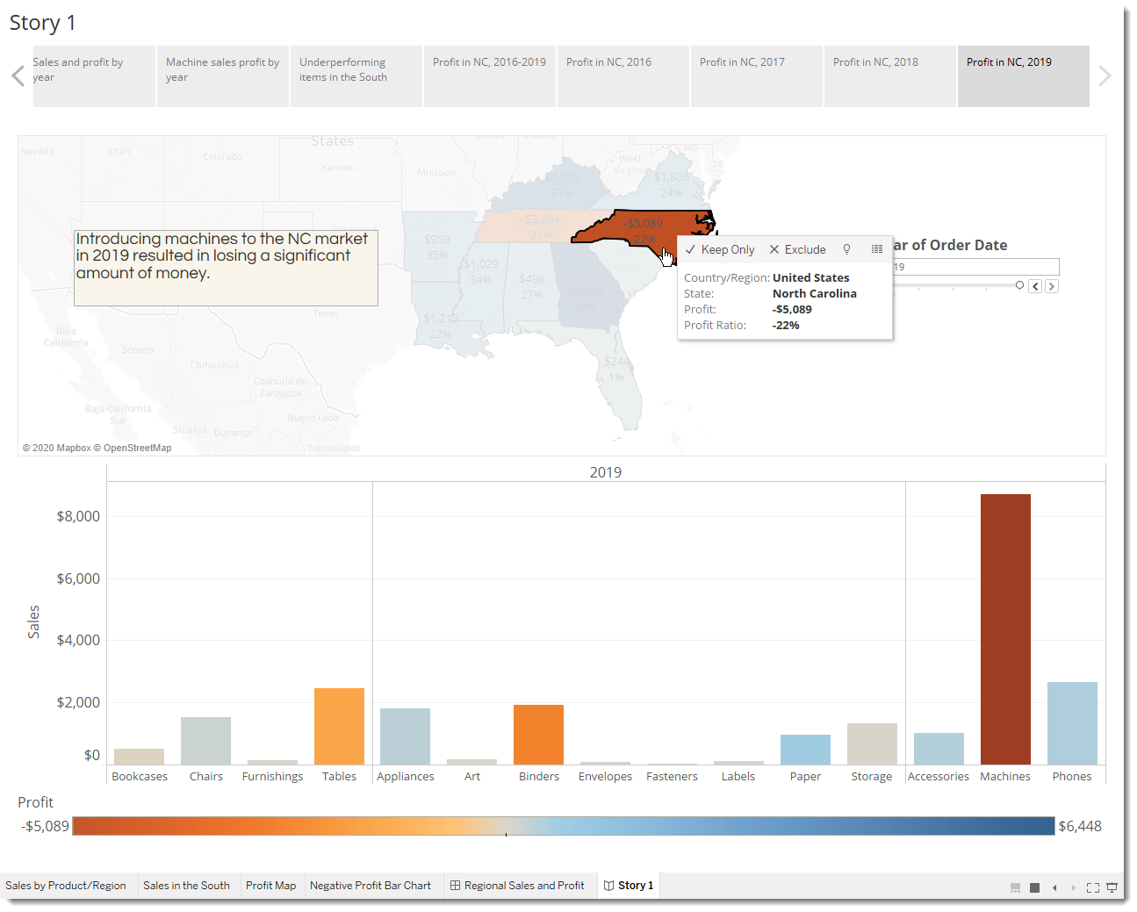For dramatic effect, you'll probably hover over Machines on the Sales in the South bar chart while presenting to show a useful tooltip: the loss of nearly $4,000.

And now, for the final slide, you drill down into the details.

1. In the Story pane, click **Blank**.
2. From the Story pane, drag **Negative Profit Bar Chart** to the view.
3. In the **Year of Order Date** filter card, narrow the view down to **2019** only.

You can now easily see that the loss of machine profits was solely from Burlington, NC.

1. In the view, right-click the **Burlington** mark (the bar) and select **Annotate** > **Mark**.
2. In the Edit Annotation dialog box that appears, delete the filler text and type: "Machines in Burlington lost nearly $4,000 in 2019."
3. Click **OK**.
4. In the view, click the annotation and drag it to adjust where if appears.
5. Give this story point the caption: "Where are we losing machine profits in NC?"
6. Double-click the **Story 1**tab and rename your story to "Improve Profits in the South".
7. Review your story by selecting **Window** > **Presentation mode**.



Click to view steps

## After you present

Your presentation went very well. The team is convinced there is work to be done to increase profit in Burlington, NC. Plus, they're curious to know why machines did so poorly in the first place. Your boss is thrilled: Not only have you identified a way to address negative profit, you've got the team asking questions about their data.

To keep the lessons fresh in their minds, your boss asks you to email your team a Word doc with your findings. Good thing you know about sharing your visualizations with Tableau Server and Tableau Public.

**Step 8: Share your findings**

You've done a bunch of work—great work—to learn that Burlington, NC needs some love. It shouldn't be difficult to share this information with your teammates. Happily, with Tableau, it isn't.

## Use Tableau Server

Your story was a hit. You're going to publish it to Tableau Server so that your team can view it online.

### **Publish to Tableau Server**

1. Select **Server** > **Publish Workbook** or click **Share**  on the toolbar.
2. Enter the name of the server (or IP address) you want to connect to in the dialog box and click **Connect**.

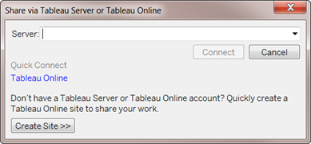

1. In the Name field, enter **Improve Profits in the South**.
2. If you want, enter a description for reference, for example "Take a look at the story I built in Tableau Desktop!"
3. Under **Sheets**, click **Edit**, and then clear all sheets except **Improve Profits in the South**.

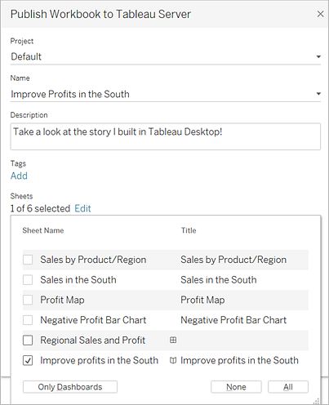

1. Click **Publish**.

Tableau Server opens in your internet browser. If prompted, enter your server credentials.

The Publishing Complete dialog box lets you know that your story is ready to view.

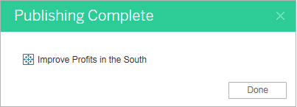

All right! You've successfully published your story using Tableau Server. Now it's time to alert the media.

### **Send a link to your work**

If not the media, it's time to alert at least your teammates so that they can interact with your story online.

1. In Tableau Server, navigate to the Improve Profits in the South story that you published. You will see a screen like this:

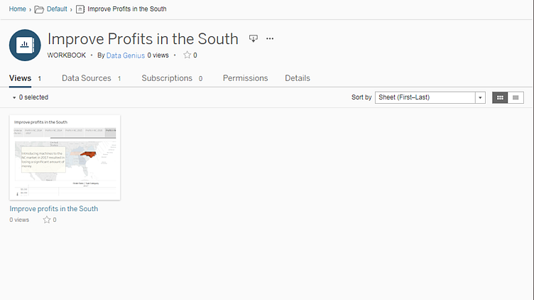

*If you had published additional sheets from your workbook, they would be listed alongside Improve Profits in the South.*

1. Click **Improve Profits in the South**.

Your screen will update to look like this:

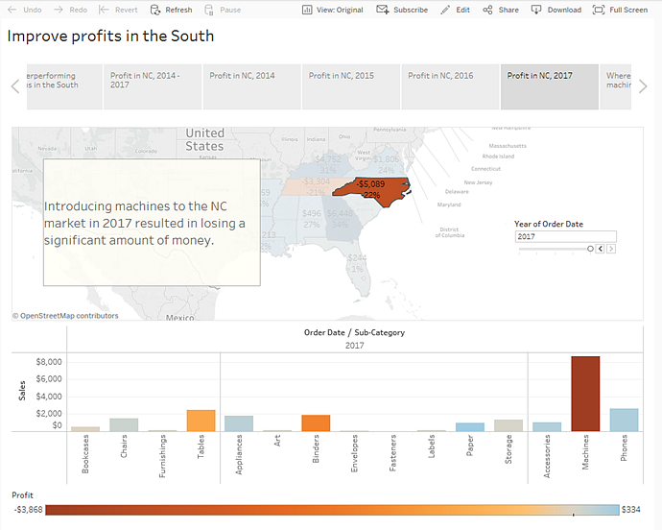

Awesome! This is your interactive, embedded story.

1. From the menu, select **Share**.

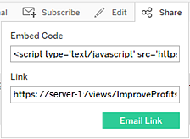

1. How do you want to share your story?
   1. Embed on your website: Copy the **Embed Code** and paste it in your web page HTML.
   2. Send a link: Copy the **Link** and send to your colleagues.
   3. Send an email using your default email client: Click the email icon.

## Congrats, you did it!

You used Tableau Desktop to create a view of your product data, map the product sales and profitability by region, build a dashboard around your findings, tell a story to present, and share your findings on the web so that remote team members can take a look.

**You're a data rockstar.**

Well done! You've successfully begun practicing the Tableau "Data Discovery" method:

* Ask a question
* Gather data
* Structure the data
* Explore the data
* Share insights

That's the basic work flow you'll follow when you work in Tableau, although you might find yourself doing a lot more revising in each stage than you did here. For example, it might take a few revisions to refine your initial question from something general (what's going on with sales?) to something specific (which city in the South is responsible for negative profit?).

And your revisions might take you off in unexpected directions. That’s great. That's what we hope will happen, that you will discover opportunities you didn't even know existed when you first looked at your data.

Bottom of Form